Занятие 4 Multimedia

Make a list of content combined in multimedia applications

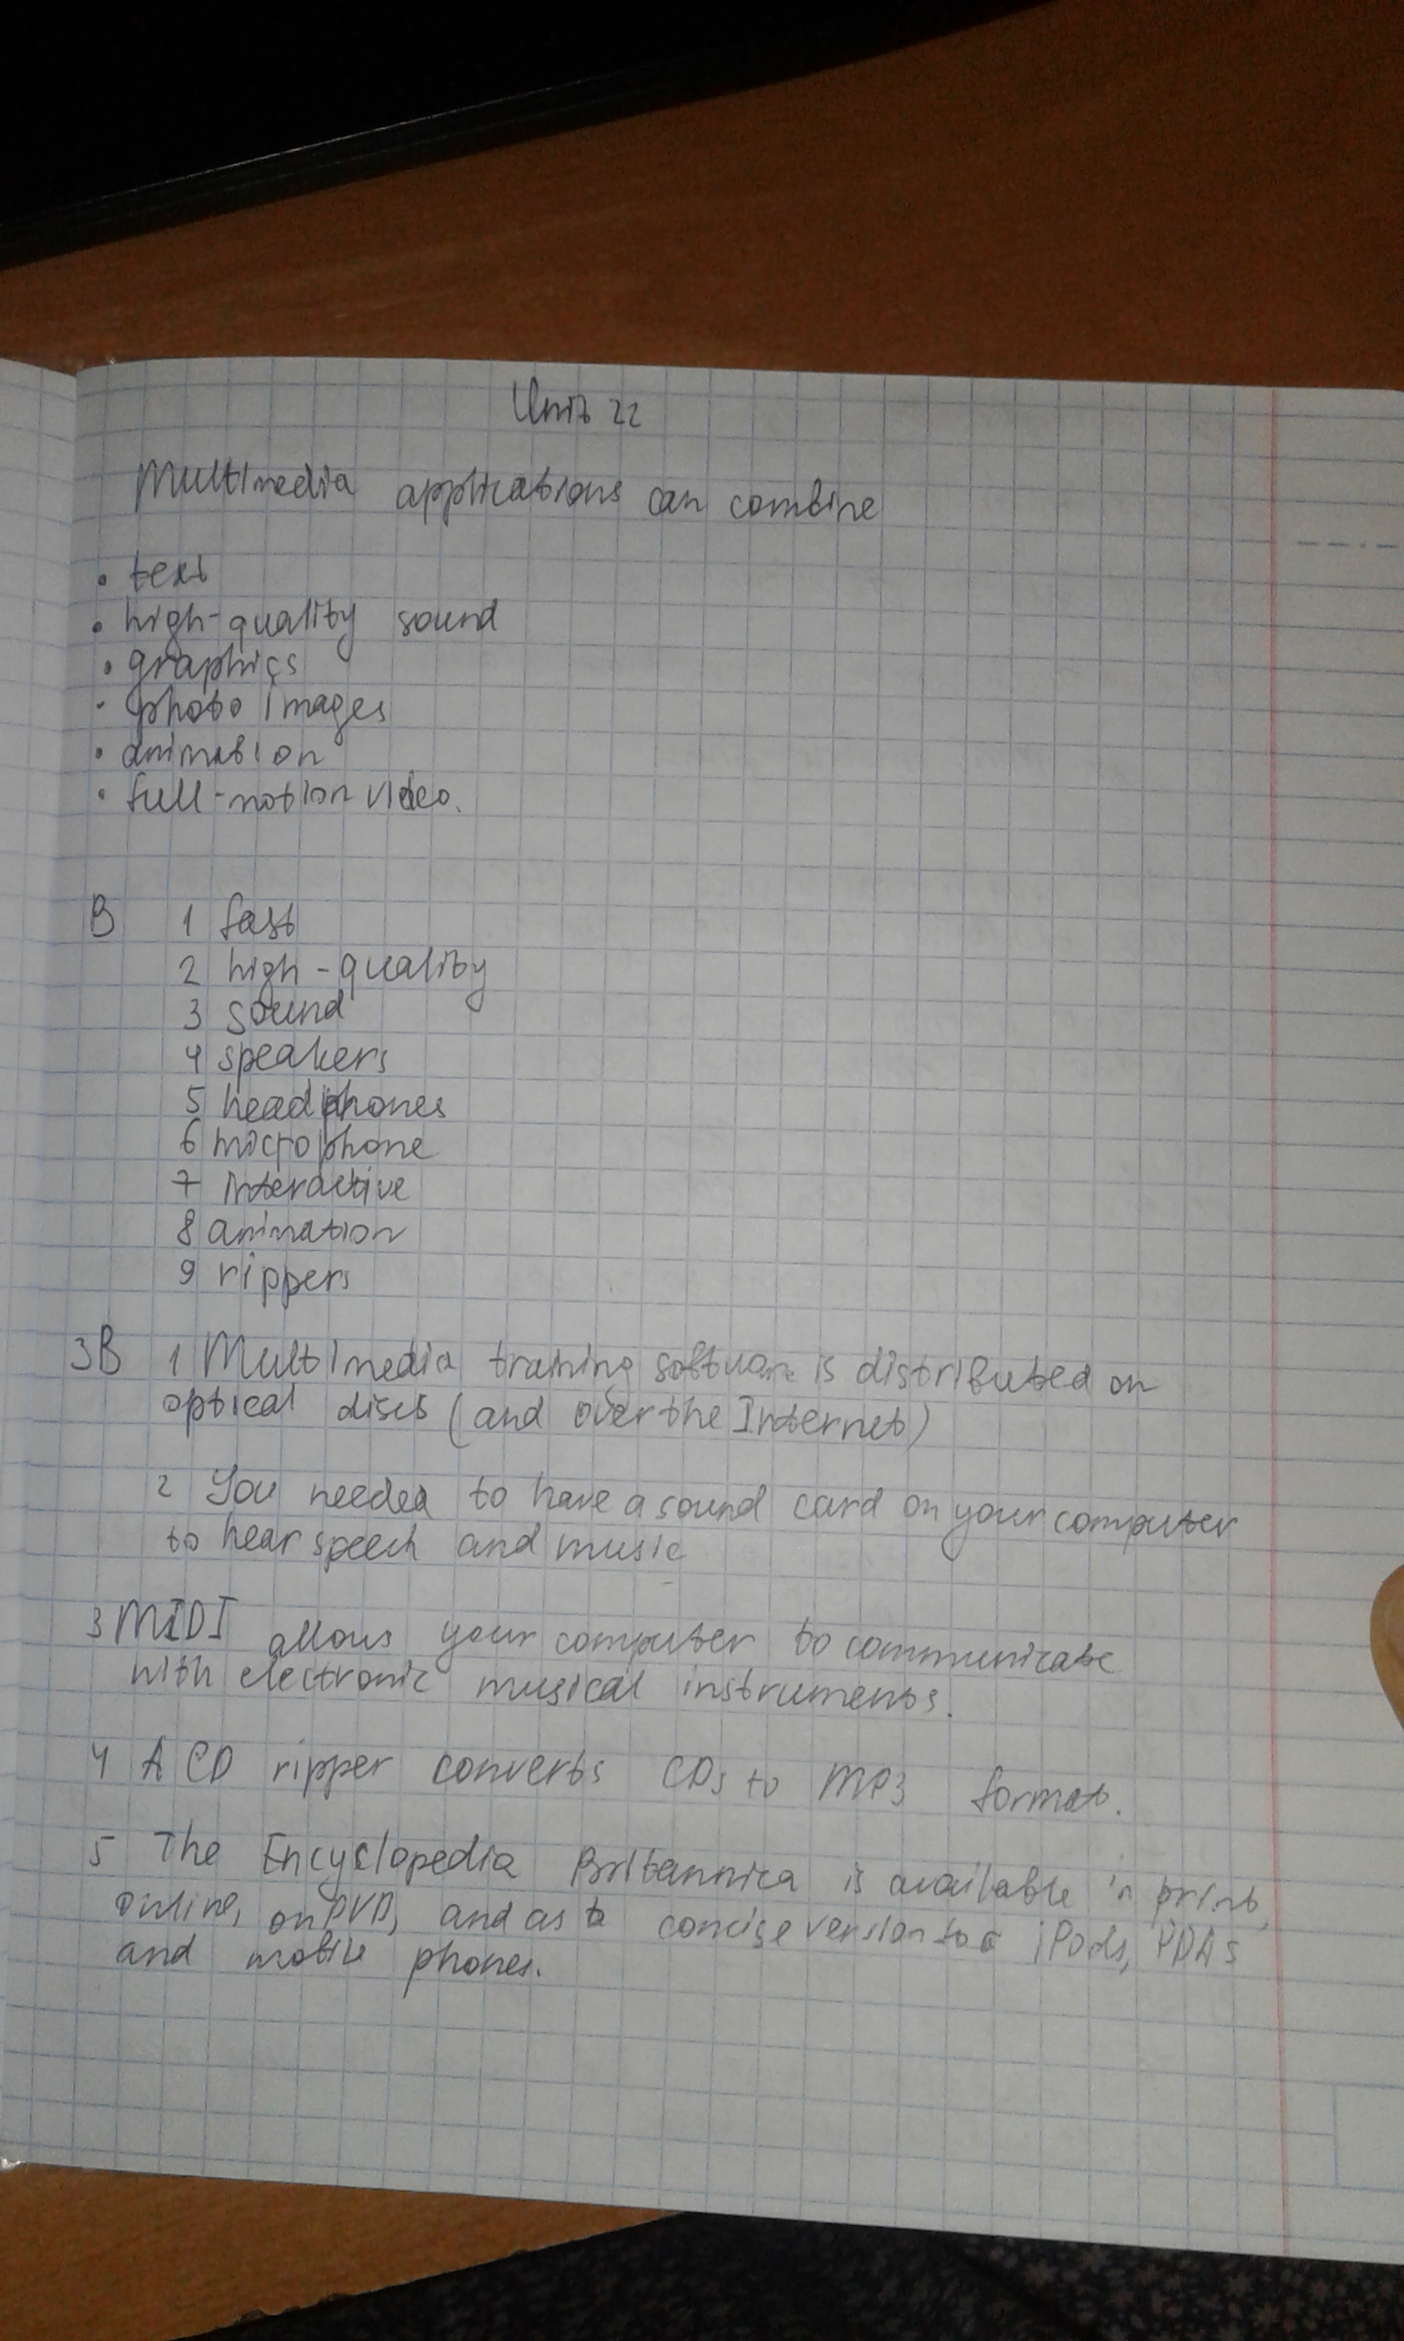

Listen to a sales assistant explanation about the system requirements needed to run multimedia software.

Listen again and complete the diagram of a multimedia system (p110)



Text- translate,25 new words learn and explain.

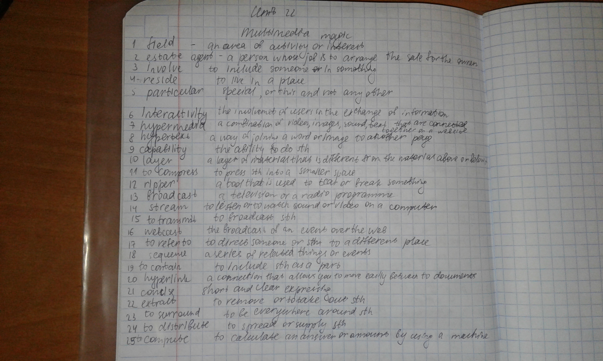



Correct the technical mistakes in these sentences (p112)

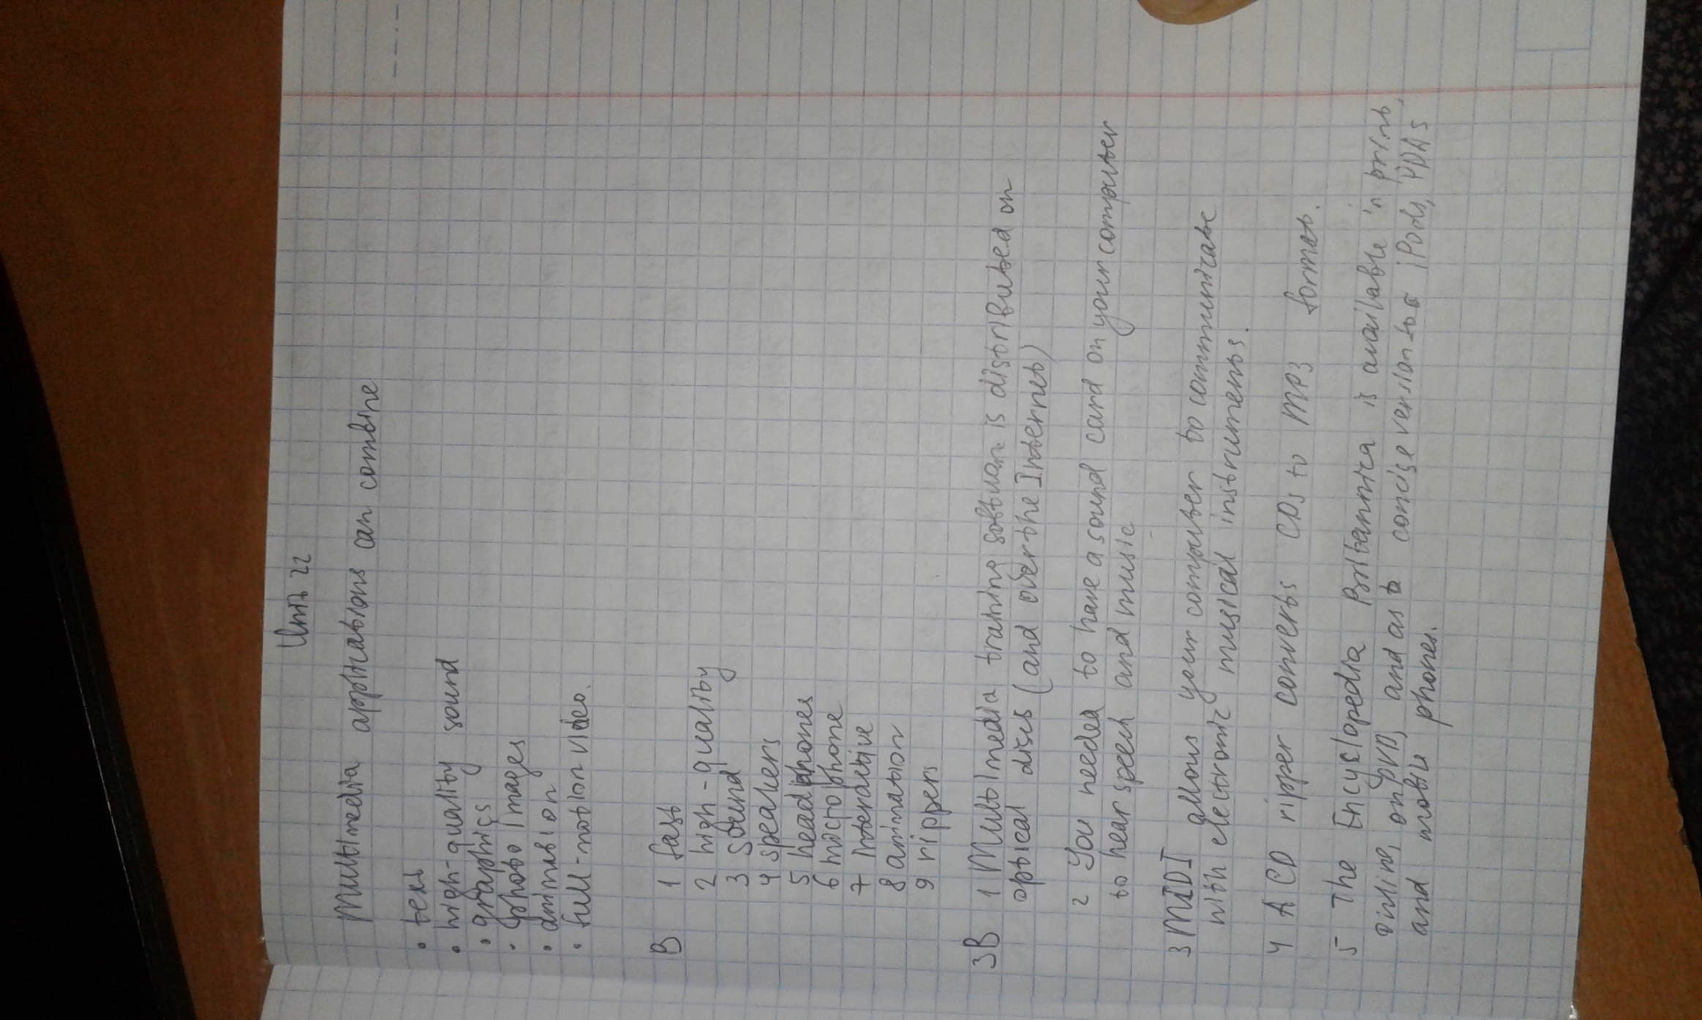

Match the description with the pictures (p113)

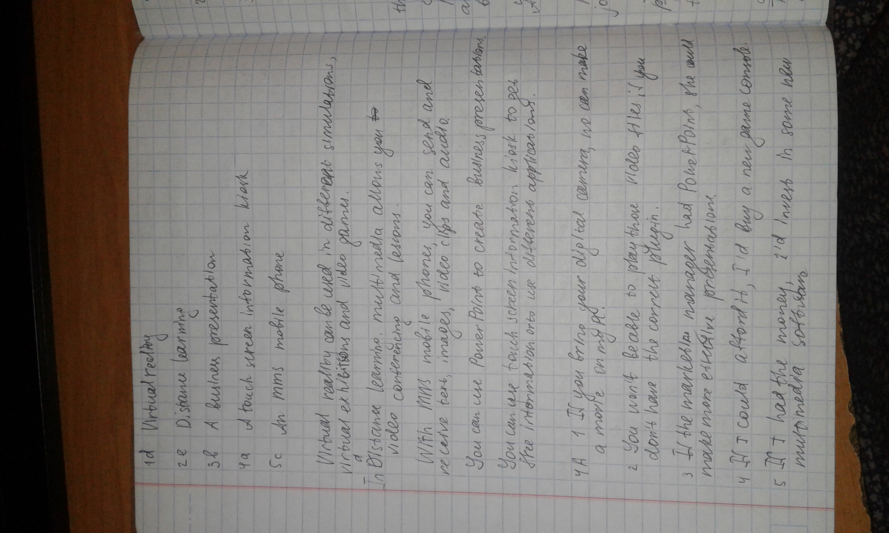

Think about the situations how multimedia is used

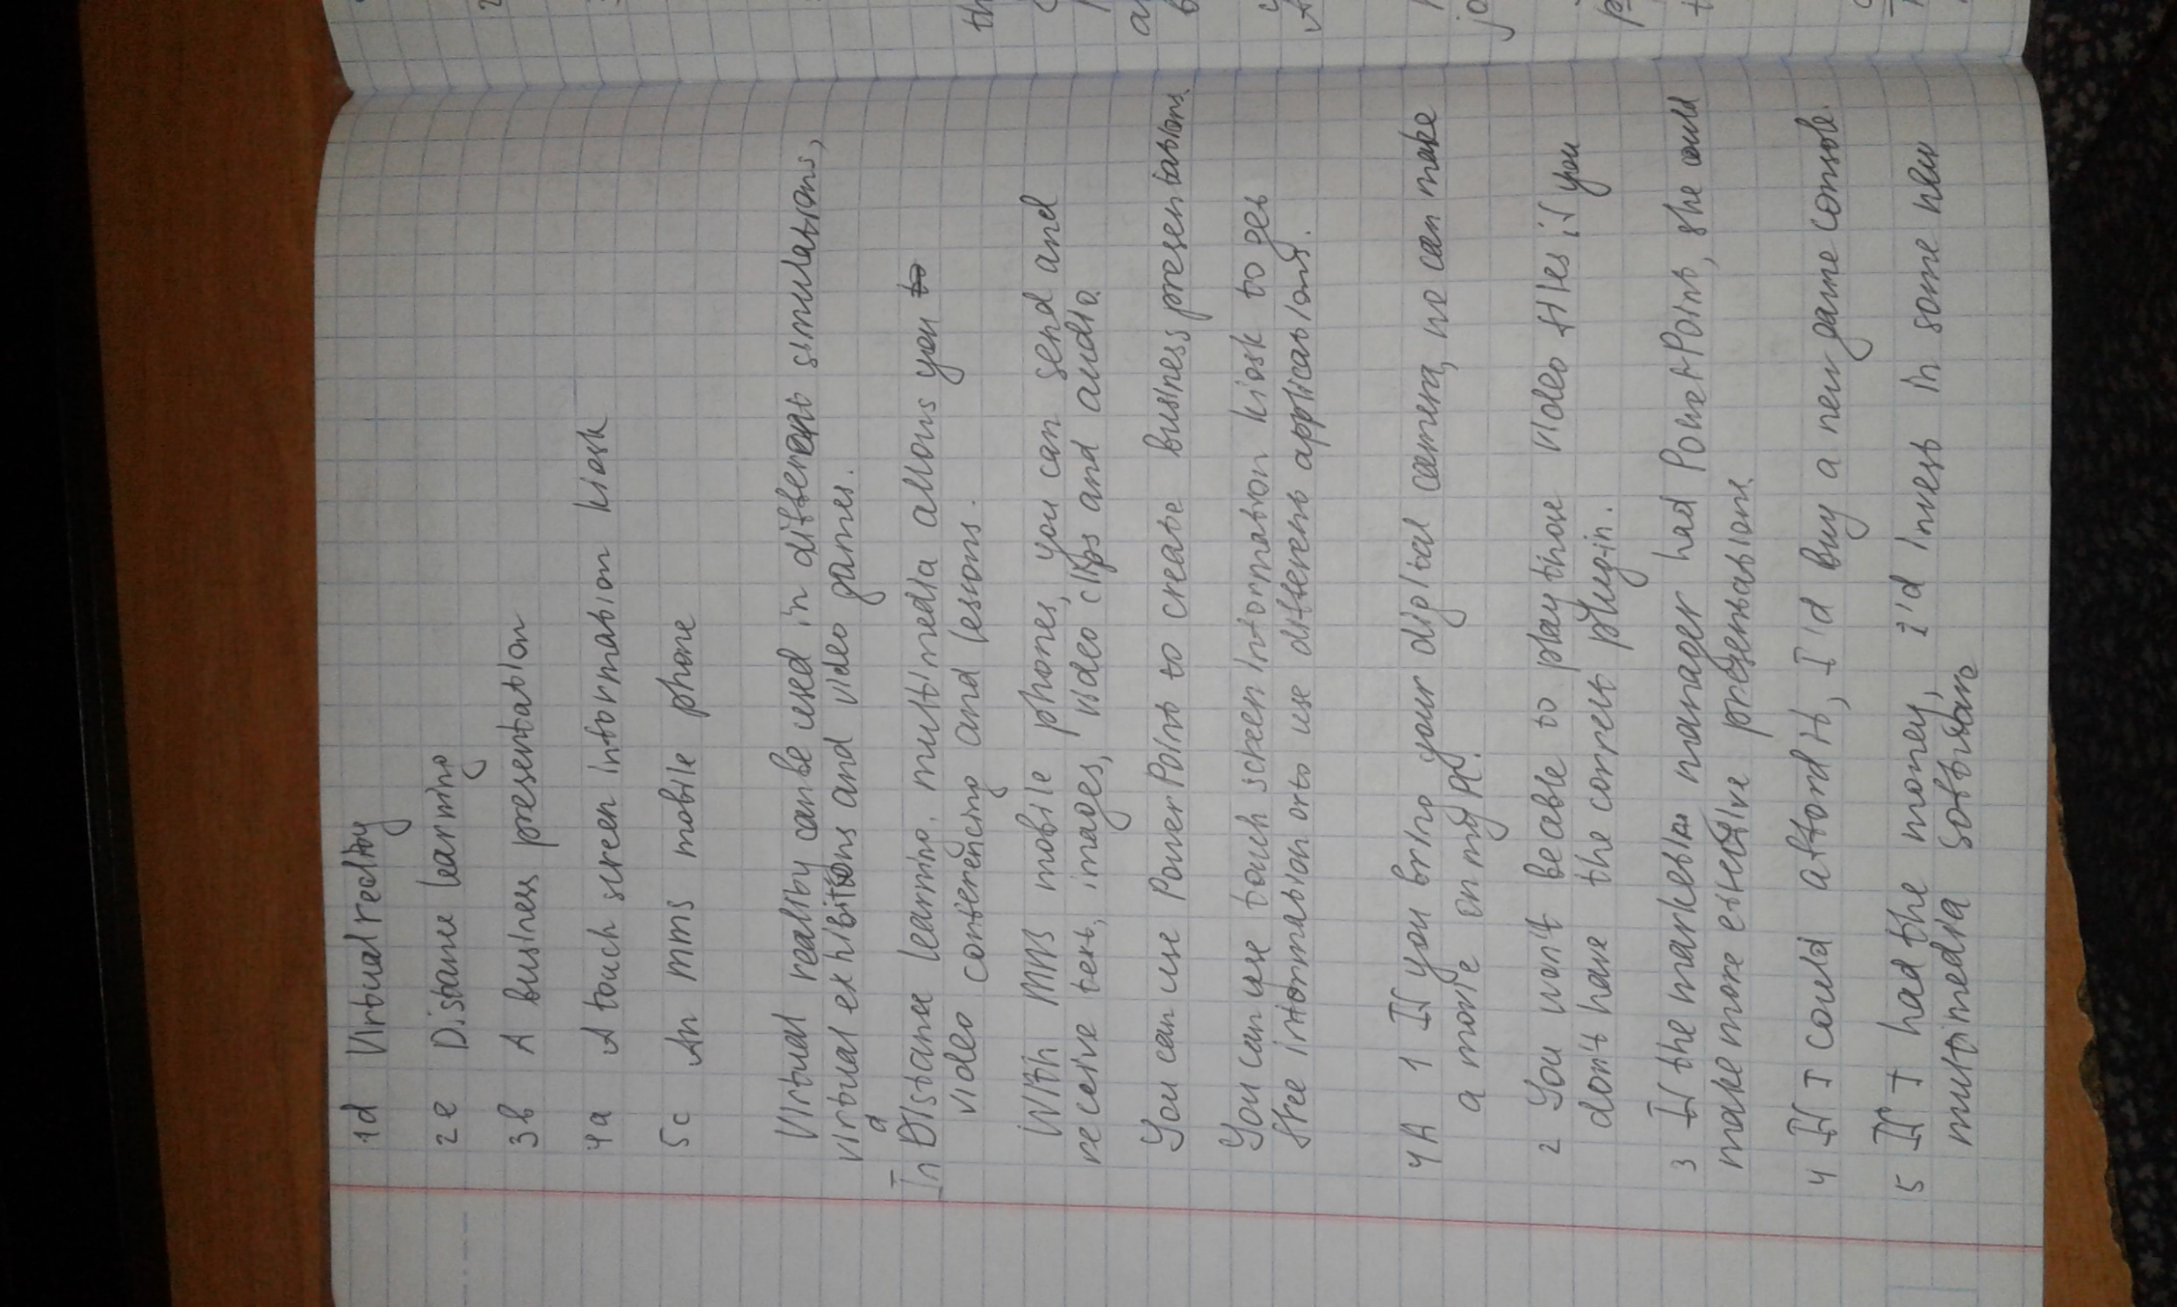

Write the report on theme The usage of Multimedia now and in the future.(250 words)

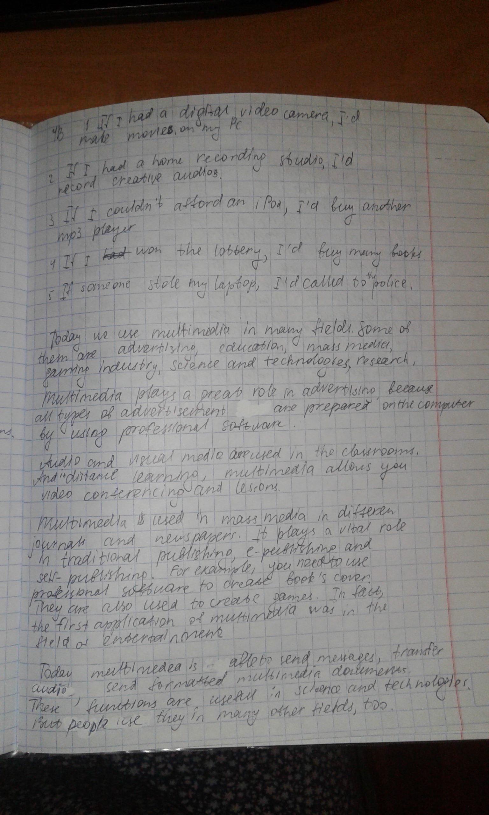



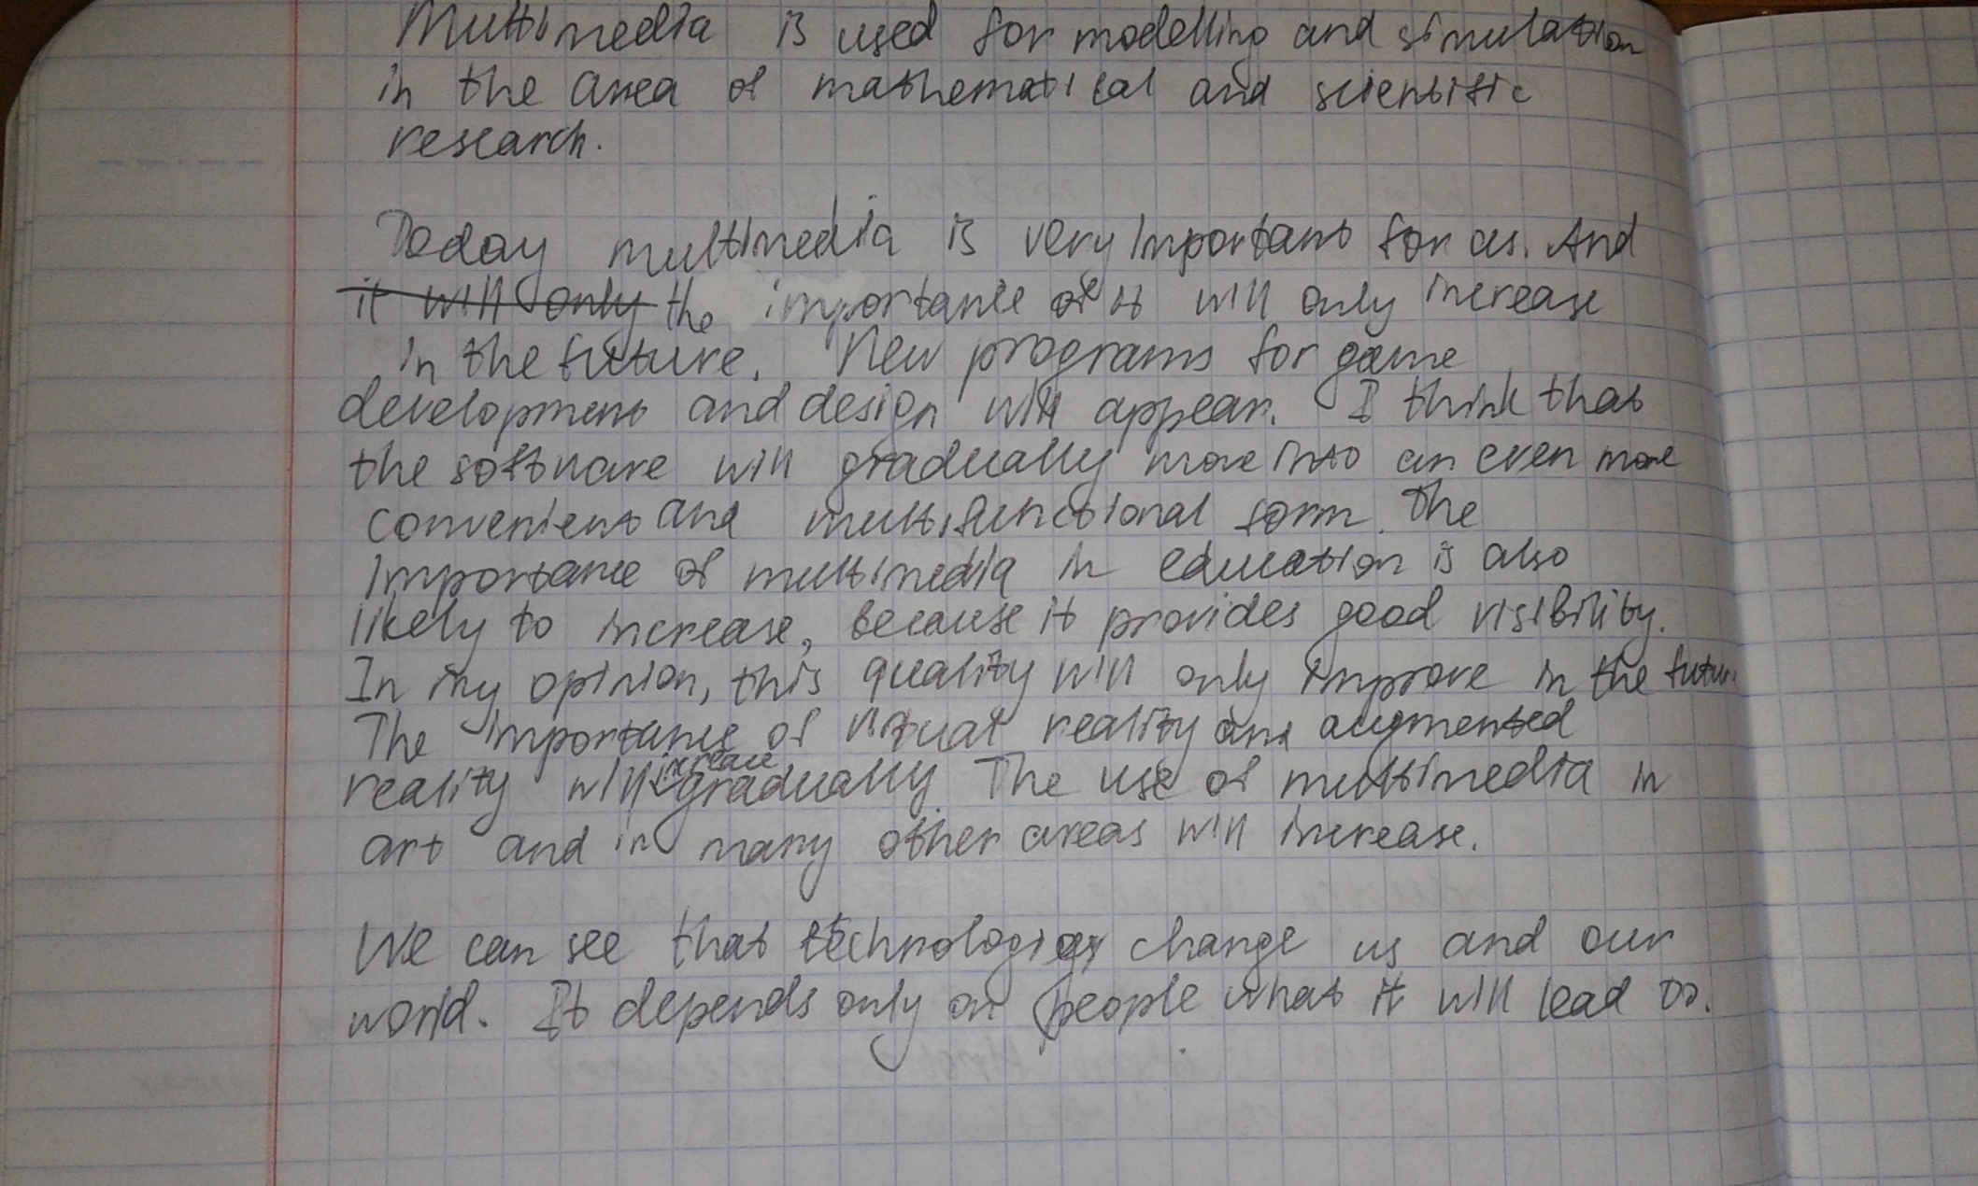

Language work Conditional sentences.(p112)

Exercises A and B (p112-113) in written form.

